BSc Computing with Software Engineering

Advanced Programming

Assignment – Phone Book

by
Michael Russell
Tutor: ***
21st December 2005

Table of Contents

Analysis 3
Design 3
Navigation Map and Storyboards 4
UML Class Diagram 5
User Guide 6
Exit 6
Load 6
Save 7
List 7
Add 8
Search 8
Testing 10
database class 10
PhoneBook and database classes 11
Program Listings 12
PhoneBook 12
database 21
UtilGUI 25
PhoneTest 26
Conclusion 27
Bibliography 28
Appendix 29

Analysis

The aim of the assignment is to build software in Java that could be used to hold contact details on a mobile phone. As such, there are certain constraints upon the project, for example, screen size.

Additionally, a database class is provided that has the method signatures present but not the implementations. This again constrains the project as new methods cannot be added, nor can the existing method signatures be amended. Some methods that I would like to see are not there and others that I don’t want are provided! For example, since some methods require you to provide the position of a record, then it would be useful to have a method to return the value of the position variable !!!

Design

The database class supplied does not dictate how the data is stored and so this has to be designed. The first thing to note is that the number of records is linked to the number of attributes due to this line:

contact = new String[noOfContact][noOfContact];

However, it doesn’t follow that the more phone book entries you have, the more contacts each entry will have. Therefore, I have simplified the matter and only the first four elements of each array entry will be used, as follows:

 | 0 | 1 | 2 | 3
contact [ ] [ ] | name | telephone | extension | details
example data | Fred | 123456 | 999 | mobile 777, work 3456

The screen dimensions implemented are those stated in the assignment; 200 x 400 pixels. Since the application is intended ultimately for a mobile phone, it is reasonable to expect such a device to have such a small screen resolution. This doesn’t give much screen estate for use by the application and so I decided that to make best use of this, I would use the CardLayout manager to enable the main screens to be stacked on top of each other. The details of the navigation order and storyboards for each screen are provided in the section below.

Navigation Map and Storyboards

Phone Book
Search
Add
List
Save
Load
Exit
0). name, tel, ext, details
Return
Standard JFileChooser
Dialog
Input name
Input telephone
Input extension
name
phone
ext.
details
Search
change
del.
search
clear
Back
BorderLayout
JTextArea
GridLayout
GridBagLayout
card ‘menu’
card ‘list’
card ‘search’

UML Class Diagram

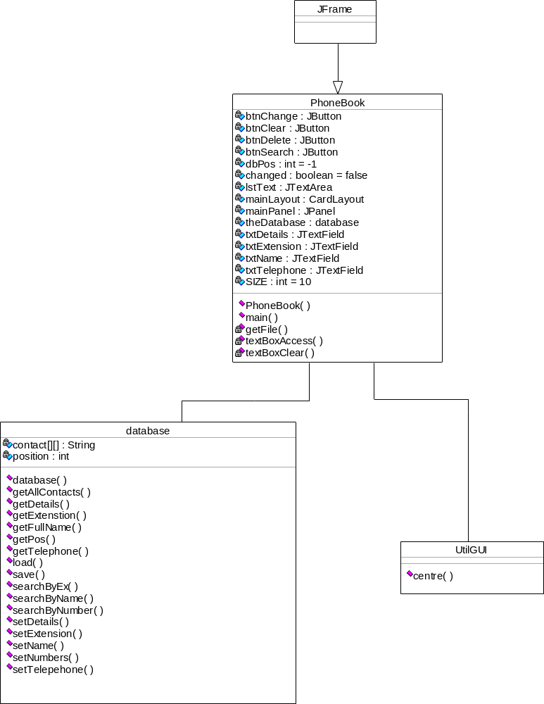

User Guide

When the program is started, the main menu will appear in the middle of the screen as follows:

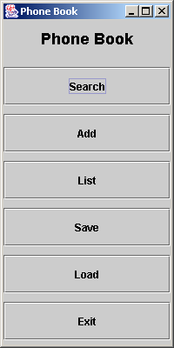

The buttons on the main menu have the following functions:

Exit

Terminates the phone book application. After pressing this key, you will be prompted to save the phone book if it has been updated.

Load

A screen will appear that allows you to select a file to load (see screen dump below). Select the correct folder and navigate to the file where the data is held and then press the Open button. If the naming convention mentioned in the save documentation has been followed, then the file will have the suffix “.pbr”. The data will load and you will return to the main menu. If you don’t want to proceed with the load then press the cancel button to return to the menu. If an error message is produced then either the file is not a phone book database or the file has become corrupt.

Note: If, when selecting this option, you have a phone book database opened that has been changed, then you will be asked if it you want to save it before loading a new one.

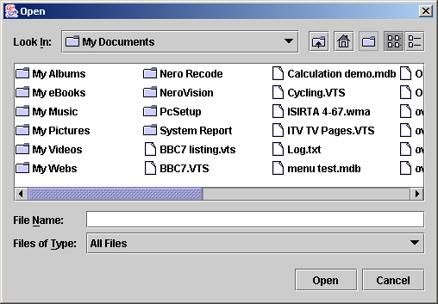

Save

A screen similar to that displayed when the load button is clicked will appear (see above). Navigate to the location where you would like to store the data and then enter the file name. It is recommended that you use a name that is a mnemonic to you and that you use the suffix ‘.pbr’, for phone book records. For example; ‘wali.pbr’. Press cancel to quit this feature without saving. You will be returned to the main menu.

List

This feature will allow you to peruse all of the records in the phone book at one time. The following screen will appear and all the records will be displayed:

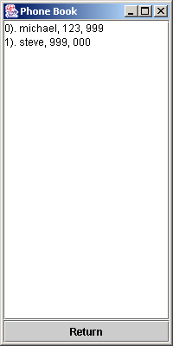

If necessary, use the scrollbars provided to view records that flow off the bottom of the screen. When you have finished, then press the button marked Return to go back to the main menu.

Add

Use this feature to add a new entry to the phone book database. You will be asked for the new entry’s name, telephone number and extension in turn using a series of input dialogs, as follows:

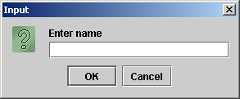

Enter the details and press ok after each entry. After being asked for these three pieces of information, you will be returned to the main menu.

If you press the cancel button at any time, then you will be returned to the main menu without the entry being added to the database, even if you have entered partial information. For example, if you enter the name and the telephone number, but press cancel when entering the extension, then none of the data will be stored.

Search

Pressing the search button will open the following screen:

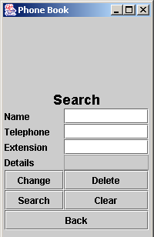

Here, you can search for a record on either the name, telephone or extension. Enter one of these three pieces of information and then press the search button. (Note: it you enter more than one piece of information then only one field will be searched. The name takes precedence over the telephone and telephone takes precedence over extension).

If the record that matches the field is found then the details will be displayed. Note: the search is case sensitive. If no match is found, then you will be notified as follows:

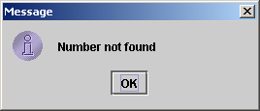

Only once a record has been found can the other keys be used, as follows:

Clear – removes any text from the name, telephone, extension and details fields so that you can start a new search. Note: This option does not delete the record displayed.

Delete – The record displayed on the screen will be permanently removed from the phone book database. You will be asked to confirm the deletion before it takes place. If you pressed this button by mistake, then select no when asked to confirm the deletion.

Change – The four fields will be displayed one at a time for you to leave as they are or amend as you wish. If you press cancel at any time, then none of the changes will be saved.

Note: The only way that additional details can be added to a record is by performing a search and subsequently using the change button. The Add facility does not give you the option of entering additional information.

Back – Pressing this button will return you to the main menu

Testing

database class

Once the database class was completed, a driver program was written to test it in isolation (See the listings section for the actual code used). The following tests are performed by the driver program:

test | method tested | lines in driver program | passed / failed
data added | setDetails | 9 to 12 | passed
database full error message | setDetails | 13 | passed
data retrieval | getFullName | 17 | passed
data retrieval | getTelephone | 18 | passed
data retrieval | getExtenstion | 19 | passed
incorrect position | setName | 21 | passed
amend record | setName | 22 | passed
amend record | setTelepehone | 23 | passed
amend record | setExtension | 24 | passed
amend record | setNumbers | 25 | passed
data retrieval | getDetails | 27 to 31 | passed
data search | searchByName | 33, 34 | passed
data search | searchByNumber | 36, 37 | passed
data search | searchByEx | 39, 40 | passed
data search | getPos | 42, 43 | passed
search item not found | searchByName | 45 - 47 | passed
saving database | save | 49 - 52 | passed
retrieval of all records | getAllContacts | 54 - 62 | passed
retrieval after deletion | getFullName | 65 | passed
retrieval after deletion | getTelephone | 66 | passed
retrieval after deletion | getExtenstion | 67 | passed
loading database | load | 69 - 72 | passed
confirmation of load | getDetails | 74-78 | passed

PhoneBook and database classes

The PhoneBook class cannot be tested in isolation. Therefore, the following integration tests were performed on the PhoneBook and database classes together:

test | expected result | actual result | passed / failed
menu, exit button | quit database | application terminated | passed
menu, exit button, database changed | asked to save before quit | asked to save | passed
menu, save button | database saved | all records saved and position pointer | passed
menu, load button | database loaded | all records loaded and position pointer restored | passed
menu, load with amended database | asked to save before load | asked to save before load | passed
menu, list button | all records shown | all records displayed | passed
list return button | menu appears | menu appeared | passed
menu, add button | asked for information, record added | record added | passed
menu, search button | search form displays | search form displayed | passed
search form, clear button | textboxes clear, record not deleted | textboxes clear, record not deleted | passed
search form, delete | record deleted | record deleted | passed
search form, search button, record not present | record not found | Corresponding details not found error message | passed
search form, search button, record present | record found | record found and displayed | passed
search form, search button, no data entered | no search criteria | “No details entered’ message | passed
search form, change button | asked for information, record updated | asked for information, record updated | passed
search form, back button | control returns to menu | control returned to menu | passed

The UtilGUI class is third party and had not been explicitly tested, although it obviously works because the application window is correctly centred on the screen.

Program Listings

PhoneBook

// Phone Book - Advanced Programming Assignment
// Michael Russell; 21st December 2005
// BSc Computing with Software Engineering, Bradford College

import javax.swing.*;
import java.awt.*;
import java.awt.event.*;
import java.io.*;

public class PhoneBook extends JFrame
{
private final int SIZE = 10;
private database theDatabase;
private int dbPos = -1;
private boolean changed = false;
private JTextArea lstText;
private CardLayout mainLayout;
private JPanel mainPanel;
private JButton btnDelete, btnChange, btnSearch, btnClear;
private JTextField txtName, txtTelephone, txtExtension, txtDetails;

public PhoneBook()
{
super("Phone Book");

theDatabase = new database(SIZE);
Container container = getContentPane();
mainLayout = new CardLayout();
mainPanel = new JPanel();
mainPanel.setLayout(mainLayout);

// *** Menu Panel ***
JPanel menu = new JPanel();
menu.setLayout(new GridLayout(7,1,10,10));

JLabel lblMain = new JLabel("Phone Book", SwingConstants.CENTER);
lblMain.setFont(new Font("Arial", Font.BOLD, 18));
menu.add(lblMain);

JButton btnFind = new JButton("Search");
btnFind.addActionListener(
new ActionListener()
{
public void actionPerformed(ActionEvent event)
{
dbPos = -1; // No record shown
textBoxClear();
textBoxAccess(true);
mainLayout.show(mainPanel, "search");
}
}
);
menu.add(btnFind);

// Name and telphone are mandatory fields
JButton btnAdd = new JButton("Add");
btnAdd.addActionListener(
new ActionListener()
{
public void actionPerformed(ActionEvent event)
{
String values [] = {"name", "telephone", "extension"};
String input [] = new String[3];
for(int loop = 0;loop < input.length; loop++)
{
input[loop] = new String("");
do
{
try
{
input[loop] = JOptionPane.showInputDialog("Enter " + values[loop]);
if(input[loop].equals("") && loop < 2)
JOptionPane.showMessageDialog(null, "Enter " + values[loop]);
}
catch(Exception e) // Cancel button pressed
{
return;
}
}while(input[loop].equals("") && loop < 2);
}
theDatabase.setDetails(input[0], input[1], input[2]);
changed = true;
}
}
);
menu.add(btnAdd);

JButton btnList = new JButton("List");
btnList.addActionListener(
new ActionListener()
{
public void actionPerformed(ActionEvent event)
{
String listing = "";
for(int loop = 0; loop < SIZE; loop++)
{
if(theDatabase.getFullName(loop) != null)
{
listing = listing.concat(loop + "). ");
listing = listing.concat(theDatabase.getDetails(loop)[0] + ", ");
listing = listing.concat(theDatabase.getDetails(loop)[1] + ", ");
listing = listing.concat(theDatabase.getDetails(loop)[2]);
if(theDatabase.getDetails(loop)[3] != null)
listing = listing.concat(", " + theDatabase.getDetails(loop)[3] + "\n");
else
listing = listing.concat("\n");
}
}
if(listing.equals(""))
listing = "No entries in the phone book";
lstText.setText(listing);
mainLayout.show(mainPanel, "list");
}
}
);
menu.add(btnList);

JButton btnSave = new JButton("Save");
btnSave.addActionListener(
new ActionListener()
{
public void actionPerformed(ActionEvent event)
{
boolean flag;
String name = "";

name = getFile(true);
if(name != null)
{
flag = theDatabase.save(name);
changed = false;
}
}
}
);
menu.add(btnSave);

JButton btnLoad = new JButton("Load");
btnLoad.addActionListener(
new ActionListener()
{
public void actionPerformed(ActionEvent event)
{
boolean flag;
String name;

if(changed == true)
{
int answer = JOptionPane.showConfirmDialog(
null,
"Save changes?",
"Save confirmation",
JOptionPane.YES_NO_OPTION);
if(answer == JOptionPane.YES_OPTION)
{
name = getFile(true);
if(name != null)
{
flag = theDatabase.save(name);
changed = false;
}
}
}
name = getFile(false);
if(name != null)
{
flag = theDatabase.load(name);
changed = false;
}
}
}
);
menu.add(btnLoad);

JButton btnExit = new JButton("Exit");
btnExit.addActionListener(
new ActionListener()
{
public void actionPerformed(ActionEvent event)
{
if(changed == true)
{
int answer = JOptionPane.showConfirmDialog(
null,
"Save changes?",
"Save confirmation",
JOptionPane.YES_NO_OPTION);
if(answer == JOptionPane.YES_OPTION)
{
String name = getFile(true);
if(name != null)
{
boolean flag = theDatabase.save(name);
}
}
}
System.exit(0);
}
}
);
menu.add(btnExit);

// *** Search Panel ***
GridBagLayout layout = new GridBagLayout();
JPanel search = new JPanel();
search.setLayout(layout);
GridBagConstraints constraints = new GridBagConstraints();

JLabel lblHeading = new JLabel("Search", SwingConstants.CENTER);
lblHeading.setFont(new Font("Arial", Font.BOLD, 18));
constraints.fill = GridBagConstraints.BOTH;
constraints.gridx=0;
constraints.gridy=0;
constraints.gridwidth = 2;
constraints.gridheight = 1;
layout.setConstraints(lblHeading, constraints);
search.add(lblHeading);

JLabel lblName = new JLabel("Name");
constraints.fill = GridBagConstraints.BOTH;
constraints.gridx=0;
constraints.gridy=1;
constraints.gridwidth = 1;
constraints.gridheight = 1;
layout.setConstraints(lblName, constraints);
search.add(lblName);

JLabel lblTelephone = new JLabel("Telephone");
constraints.gridx=0;
constraints.gridy=2;
constraints.gridwidth = 1;
constraints.gridheight = 1;
layout.setConstraints(lblTelephone, constraints);
search.add(lblTelephone);

JLabel lblExtension = new JLabel("Extension");
constraints.gridx=0;
constraints.gridy=3;
constraints.gridwidth = 1;
constraints.gridheight = 1;
layout.setConstraints(lblExtension, constraints);
search.add(lblExtension);

JLabel lblDetails = new JLabel("Details");
constraints.gridx=0;
constraints.gridy=4;
constraints.gridwidth = 1;
constraints.gridheight = 1;
layout.setConstraints(lblDetails, constraints);
search.add(lblDetails);

txtName = new JTextField(10);
constraints.gridx=1;
constraints.gridy=1;
constraints.gridwidth = 1;
constraints.gridheight = 1;
layout.setConstraints(txtName, constraints);
search.add(txtName);

txtTelephone = new JTextField(10);
constraints.gridx=1;
constraints.gridy=2;
constraints.gridwidth = 1;
constraints.gridheight = 1;
layout.setConstraints(txtTelephone, constraints);
search.add(txtTelephone);

txtExtension = new JTextField(10);
constraints.gridx=1;
constraints.gridy=3;
constraints.gridwidth = 1;
constraints.gridheight = 1;
layout.setConstraints(txtExtension, constraints);
search.add(txtExtension);

txtDetails = new JTextField(10);
constraints.gridx=1;
constraints.gridy=4;
constraints.gridwidth = 1;
constraints.gridheight = 1;
layout.setConstraints(txtDetails, constraints);
search.add(txtDetails);
txtDetails.setEditable(false);

// Name and telephone are mandatory fields
btnChange = new JButton("Change");
btnChange.addActionListener(
new ActionListener()
{
public void actionPerformed(ActionEvent event)
{
if(dbPos == -1)
JOptionPane.showMessageDialog(null, "No record present");
else
{
String values [] = {"name", "telephone", "extension", "details"};
String input [] = new String[4];
input[0] = txtName.getText();
input[1] = txtTelephone.getText();
input[2] = txtExtension.getText();
input[3] = txtDetails.getText();
for(int loop = 0;loop < input.length; loop++)
{
do
{
try
{
input[loop] = (String)JOptionPane.showInputDialog(
null,
"Enter " + values[loop],
"Change entry",
JOptionPane.PLAIN_MESSAGE,
null,
null,
input[loop]
);
if(input[loop].equals("") && loop < 2)
JOptionPane.showMessageDialog(null, "Enter " + values[loop]);
}
catch(Exception e) // Cancel button pressed
{
return;
}
}while(input[loop].equals("") && loop < 2);
}
txtName.setText(input[0]);
txtTelephone.setText(input[1]);
txtExtension.setText(input[2]);
txtDetails.setText(input[3]);
theDatabase.setName(input[0], dbPos);
theDatabase.setTelepehone(input[1],dbPos);
theDatabase.setExtension(input[2], dbPos);
theDatabase.setNumbers(input[3], dbPos);
changed = true;
}
}
}
);
constraints.gridx = 0;
constraints.gridy = 5;
constraints.gridwidth = 1;
constraints.gridheight = 1;
layout.setConstraints(btnChange, constraints);
search.add(btnChange);

btnClear = new JButton("Clear");
btnClear.addActionListener(
new ActionListener()
{
public void actionPerformed(ActionEvent event)
{
dbPos = -1; // No record shown
textBoxClear();
textBoxAccess(true);
}
}
);
constraints.gridx = 1;
constraints.gridy = 6;
constraints.gridwidth = 1;
constraints.gridheight = 1;
layout.setConstraints(btnClear, constraints);
search.add(btnClear);

btnDelete = new JButton("Delete");
btnDelete.addActionListener(
new ActionListener()
{
public void actionPerformed(ActionEvent event)
{
if(dbPos == -1)
JOptionPane.showMessageDialog(null, "No current record");
else
{
int answer = JOptionPane.showConfirmDialog(
null,
"Are you sure you want to delete this record?",
"Deletion confirmation",
JOptionPane.YES_NO_OPTION);
if(answer == JOptionPane.YES_OPTION)
{
theDatabase.setName( null, dbPos);
theDatabase.setTelepehone( null, dbPos);
theDatabase.setExtension( null, dbPos);
theDatabase.setNumbers( null, dbPos);
textBoxClear();
textBoxAccess(true);
dbPos = -1;
changed = true;
}
}
}
}
);
constraints.gridx = 1;
constraints.gridy = 5;
constraints.gridwidth = 1;
constraints.gridheight = 1;
layout.setConstraints(btnDelete, constraints);
search.add(btnDelete);

btnSearch = new JButton("Search");
btnSearch.addActionListener(
new ActionListener()
{
public void actionPerformed(ActionEvent event)
{
// Search;
if(!txtName.getText().equals(""))
{
// search on name
int result = theDatabase.searchByName(txtName.getText());
if(result == -1)
JOptionPane.showMessageDialog(null, "Name not found");
else
{
dbPos = result;
txtTelephone.setText(theDatabase.getTelephone(dbPos));
txtExtension.setText(theDatabase.getExtenstion(dbPos));
textBoxAccess(false);
}
}
else if (!txtTelephone.getText().equals(""))
{
// search on telephone
int result = theDatabase.searchByNumber(txtTelephone.getText());
if(result == -1)
JOptionPane.showMessageDialog(null, "Number not found");
else
{
dbPos = result;
txtName.setText(theDatabase.getFullName(dbPos));
txtExtension.setText(theDatabase.getExtenstion(dbPos));
textBoxAccess(false);
}
}
else if (!txtExtension.getText().equals(""))
{
// search on extension
int result = theDatabase.searchByEx(txtExtension.getText());
if(result == -1)
JOptionPane.showMessageDialog(null, "Number not found");
else
{
dbPos = result;
txtName.setText(theDatabase.getFullName(dbPos));
txtTelephone.setText(theDatabase.getTelephone(dbPos));
textBoxAccess(false);
}
}
else
// error no details entered
JOptionPane.showMessageDialog(null, "No details entered");
}
}
);
constraints.gridx = 0;
constraints.gridy = 6;
constraints.gridwidth = 1;
constraints.gridheight = 1;
layout.setConstraints(btnSearch, constraints);
search.add(btnSearch);

JButton btnBack = new JButton("Back");
btnBack.addActionListener(
new ActionListener()
{
public void actionPerformed(ActionEvent event)
{
mainLayout.show(mainPanel, "menu");
}
}
);
constraints.gridx = 0;
constraints.gridy = 7;
constraints.gridwidth = 2;
constraints.gridheight = 1;
layout.setConstraints(btnBack, constraints);
search.add(btnBack);

// *** List Panel ***
JPanel list = new JPanel();
list.setLayout(new BorderLayout());
JButton btnReturn = new JButton("Return");
btnReturn.addActionListener(
new ActionListener()
{
public void actionPerformed(ActionEvent event)
{
mainLayout.show(mainPanel, "menu");
}
}
);
list.add(btnReturn, BorderLayout.SOUTH);

lstText = new JTextArea(5,5);
list.add(new JScrollPane(lstText), BorderLayout.CENTER);

mainPanel.add(menu, "menu");
mainPanel.add(search, "search");
mainPanel.add(list, "list");

container.add(mainPanel, BorderLayout.CENTER);
setSize(200,400);
UtilGUI.centre(this);
setVisible(true);
}

private void textBoxClear()
{
txtName.setText("");
txtTelephone.setText("");
txtExtension.setText("");
txtDetails.setText("");
}

private void textBoxAccess(boolean state)
{
txtName.setEditable(state);
txtTelephone.setEditable(state);
txtExtension.setEditable(state);
}

// save dialog if true passed, else open
private String getFile(boolean save)
{
int result;
File filename;

do
{
JFileChooser fileChooser = new JFileChooser();
fileChooser.setFileSelectionMode(JFileChooser.FILES_ONLY);
if(save)
result = fileChooser.showSaveDialog(this);
else
result = fileChooser.showOpenDialog(this);
if(result == JFileChooser.CANCEL_OPTION)
return null;
filename = fileChooser.getSelectedFile();
}while(filename == null || filename.getName().equals(""));

return filename.getPath();
}

public static void main(String[] args)
{
PhoneBook program = new PhoneBook();

program.setDefaultCloseOperation(JFrame.EXIT_ON_CLOSE);
}

}

database

// Phone Book - Advanced Programming Assignment
// Michael Russell; 21st December 2005
// BSc Computing with Software Engineering, Bradford College

//NOTE TO STUDENT
//---------------
//Please do NOT alter method names or name of class

//addition imports can be added if needed

import java.io.*;
import java.util.*;
import javax.swing.*; // needed for JOptionPane

// CLASSES SHOULD ALWAYS START WITH A CAPITAL LETTER !!!!!!!
public class database
{
String[][] contact;
int position = 0;

public database(int noOfContact)
{
if(noOfContact <4) // won't work unless at least 4 places for fields
noOfContact = 4;
contact = new String[noOfContact][noOfContact]; // no. of fields linked to no. of records??
}

public void setDetails(String name, String tel, String exten)
{
if(position == contact.length) // can't resize array, so error
JOptionPane.showMessageDialog(null, "Storage full", "Error message", JOptionPane.ERROR_MESSAGE);
else
{
contact[position][0] = name;
contact[position][1] = tel;
contact[position++][2] = exten;
}
}

public void setName( String name, int pos)
{
try
{
contact[pos][0] = name;
}
catch(ArrayIndexOutOfBoundsException e)
{
JOptionPane.showMessageDialog(null, "array position does not exist", "Error message", JOptionPane.ERROR_MESSAGE);
}

}

public void setTelepehone(String tel, int pos) // spelling mistake
{
try
{
contact[pos][1] = tel;
}
catch(ArrayIndexOutOfBoundsException e)
{
JOptionPane.showMessageDialog(null, "array position does not exist", "Error message", JOptionPane.ERROR_MESSAGE);
}

}

public void setExtension(String exten, int pos)
{
try
{
contact[pos][2] = exten;
}
catch(ArrayIndexOutOfBoundsException e)
{
JOptionPane.showMessageDialog(null, "array position does not exist", "Error message", JOptionPane.ERROR_MESSAGE);
}

}

public void setNumbers(String num, int pos)
{
try
{
contact[pos][3] = num;
}
catch(ArrayIndexOutOfBoundsException e)
{
JOptionPane.showMessageDialog(null, "array position does not exist", "Error message", JOptionPane.ERROR_MESSAGE);
}

}

public String getFullName(int pos)
{
if(pos < contact.length)
return contact[pos][0];
else
return null;
}
public String getTelephone(int pos)
{
if(pos < contact.length)
return contact[pos][1];
else
return null;
}

public String getExtenstion(int pos) // Spelling mistake
{
if(pos < contact.length)
return contact[pos][2];
else
return null;
}

public String[] getDetails(int pos)
{
if(pos < contact.length)
return contact[pos];
else
return null;
}

// Linear search
// returns -1 if name not found
public int searchByName(String s)
{
int found = -1;
for(int loop = 0; loop < position; loop++)
if(s.equals(contact[loop][0]))
found = loop;
return found;
}

// Returns -1 if name not found
// Not allowed to make new methods so search code repeated here - forced into bad programming
public int searchByNumber(String num)
{
int found = -1;
for(int loop = 0; loop < position; loop++)
if(num.equals(contact[loop][1]))
found = loop;
return found;
}

// Returns -1 if name not found
// search code repeated again !!
public int searchByEx(String ex)
{
int found = -1;
for(int loop = 0; loop < position; loop++)
if(ex.equals(contact[loop][2]))
found = loop;
return found;
}

public String[][] getAllContacts()
{
return contact;
}

// change int to string and pass to tel no. search
public int getPos(int tel)
{
return searchByNumber(String.valueOf(tel));
}

public boolean save(String file)
{
boolean b = false;
try
{
ObjectOutputStream output = new ObjectOutputStream(new FileOutputStream(file));
output.writeInt(position);
output.writeObject(contact);
output.close();
}
catch(Exception e)
{
JOptionPane.showMessageDialog(null, e.getMessage(), "Error message", JOptionPane.ERROR_MESSAGE);
b = true;
}
return b;
}

public boolean load(String file)
{
boolean b = false;
try
{
ObjectInputStream input = new ObjectInputStream(new FileInputStream(file));
position = input.readInt();
contact = (String[][]) input.readObject();
input.close();
}
catch(Exception e)
{
JOptionPane.showMessageDialog(null, "load failure", "Error message", JOptionPane.ERROR_MESSAGE);
b = true;
}
return b;
}
}

UtilGUI

// Phone Book - Advanced Programming Assignment
// Michael Russell; 21st December 2005
// BSc Computing with Software Engineering, Bradford College

// This code is taken from the class notes "Centering a main window"

import java.awt.*;

public class UtilGUI
{
/** Centre a Window, Frame, JFrame, Dialog, etc. */
public static void centre(Window w)
{
// After packing a Frame or Dialog, centre it on the screen.
Dimension us = w.getSize( ),
them = Toolkit.getDefaultToolkit( ).getScreenSize( );
int newX = (them.width - us.width) / 2;
int newY = (them.height- us.height)/ 2;
w.setLocation(newX, newY);
}
}

PhoneTest

// Driver class to test all Phone Book methods. M.Russell 21/12/2005
public class PhoneTest
{
public static void main(String[] args)
{
final int SIZE = 4;
database phoneBook = new database(SIZE);

phoneBook.setDetails("Michael","433115", "123");
phoneBook.setDetails("Police","999", "999");
phoneBook.setDetails("Mary","987", "321");
phoneBook.setDetails("Ahmed","578", "989");
phoneBook.setDetails("Sarah","345", "478");

System.out.println("Details for position zero: ");
System.out.println("Name : " + phoneBook.getFullName(0));
System.out.println("Telephone : " + phoneBook.getTelephone(0));
System.out.println("Extension : " + phoneBook.getExtenstion(0));

phoneBook.setName("Fred",11); // Induce error
phoneBook.setName("Fred",0);
phoneBook.setTelepehone("123456",0);
phoneBook.setExtension("1234",0);
phoneBook.setNumbers("mobile 08956 253689",0);

System.out.println("\nDetails for position zero: ");
String details [] = new String [SIZE];
details = phoneBook.getDetails(0);
for(int loop = 0; loop <SIZE; loop++)
System.out.print(details[loop] + ", ");

int found = phoneBook.searchByName("Ahmed");
System.out.println("\nAhmed found at " + found);

found = phoneBook.searchByNumber("999");
System.out.println("999 found at " + found);

found = phoneBook.searchByEx("321");
System.out.println("321 found at " + found);

found = phoneBook.getPos(123456);
System.out.println("123456 found at " + found);

found = phoneBook.searchByName("Steve");
if(found == -1)
System.out.println("Steve not found");

if(phoneBook.save("test.tmp"))
System.out.println("save failed");
else
System.out.println("save successful");

String [][] records = phoneBook.getAllContacts();

for(int tmp = 0; tmp<records.length; tmp++)
{
records[0][0]="";
records[0][1]="";
records[0][2]="";
records[0][3]="";
}

System.out.println("Details for position zero: ");
System.out.println("Name : " + phoneBook.getFullName(0));
System.out.println("Telephone : " + phoneBook.getTelephone(0));
System.out.println("Extension : " + phoneBook.getExtenstion(0));

if(phoneBook.load("test.tmp"))
System.out.println("load failed");
else
System.out.println("load successful");

System.out.println("\nDetails for position zero: ");
details = phoneBook.getDetails(0);
for(int loop = 0; loop <SIZE; loop++)
System.out.print(details[loop] + ", ");
System.out.println();
System.exit(0);
}
}

Conclusion

Although the program works satisfactorily, the code could be shortened where lines are repeated. For example, when using the GridBagLayout, the components and the GridBag constraint values could be placed into arrays and initialised using loops.

It would be better to constrain the file type when using the JFileChooser, however, I couldn’t get the code to perform a file filter to work on my system.

Bibliography

Akbar, W. (2005). Centering a Main Window. Bradford, Bradford College

Akbar, W. (2005). Choosing a File with JFileChooser. Bradford, Bradford College

Bennett, S. , McRobb, S. & Farmer, R. (2002). Object-Oriented Systems Analysis and Design Using UML 2nd edition. Maidenhead: McGraw Hill

Deitel, H & Deitel, P. (2002). Java How To Program 4th edition. Upper Saddle River, Prentice-Hall.

Parsons, D. (1998). Introductory Java 1st edition. London, Letts Educational

Sun Microsystems Limited. (2003). JavaTM 2 Platform, Standard Edition, v 1.4.2 API Specification [Internet]. Available from <java.sun.com/j2se/1.4.2/docs/api/index.htm> [Accessed 06 November 2003].

Appendix

Items contained in this section include:

- Search form design and details for GridBagLayout constraints

- Nav. Map & storyboard initial design

- CDROM containing source code

- Original assignment brief

- Declaration of Authenticity

